# ECE792-038 Homework Assignment #1 Basic Topics Due Monday, September 17, 2018

**No late homework will be accepted**; turn in whatever you have completed. **Provide CLI output/Screenshot to support your answer**

**Problem 1.** *(10 Points)* **Basic Linux network verification tasks.** Using the CLI Utility, show the following default configurations of your machine:

1. Interfaces

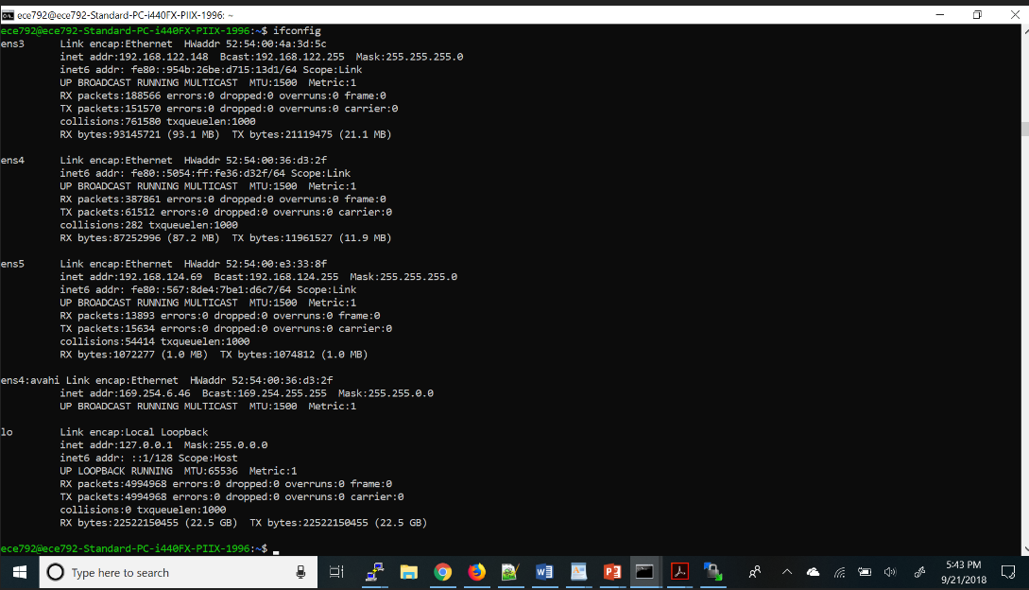

2.Routing table

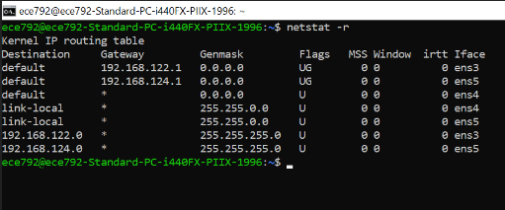

1. DNS

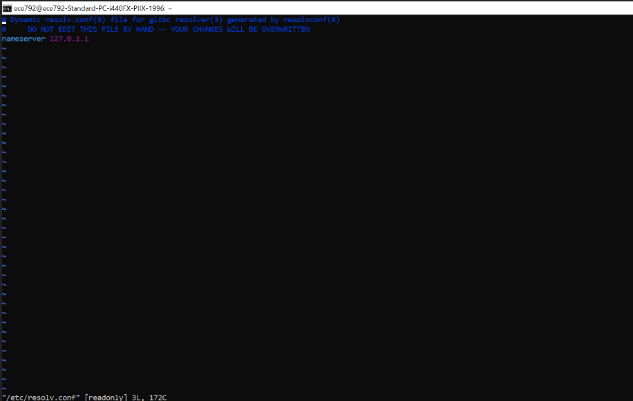

1. DHCP (You might need to look at some configurations file)

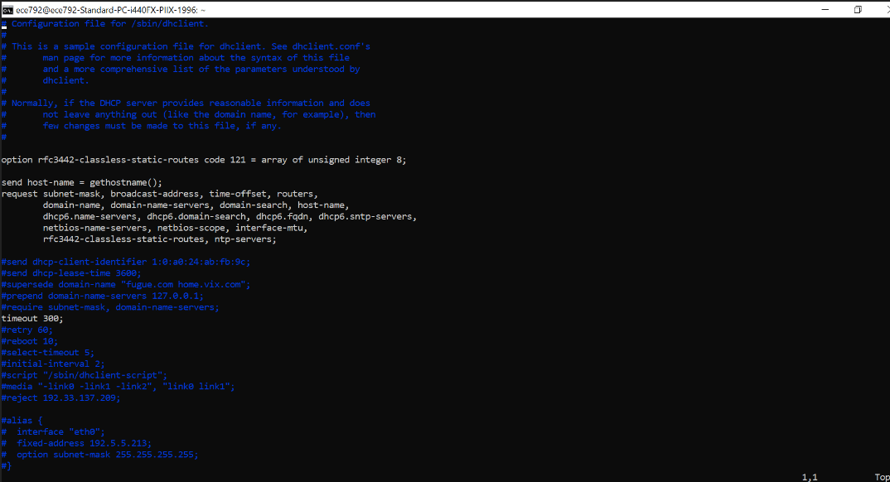

**Problem 2.** *(10 Points)* **Basic Linux performance verification tasks.** Using the CLI Utility, show following performance stats of your machine.

1. **CPU usage:** Display three reports of statistics for all processors at two second intervals. Which CPU is least used (*idle* most of the time)?

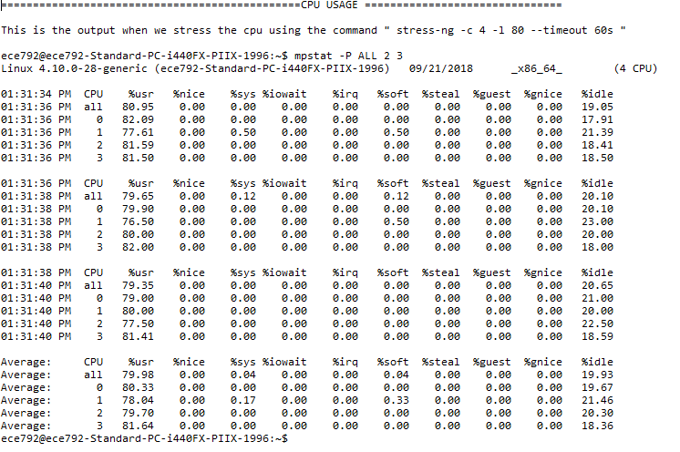

From the results of CLI output the least used CPU is CPU 1 as it has more percentage of IDLE time (21.46%)

when system is idle we got the corresponding result:

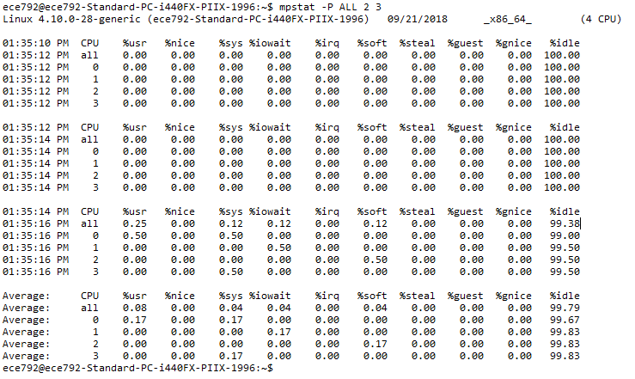

Here the idle time for all the CPUs are 100%

1. **Memory usage:** Display 3 reports of MEM statistics for every active task in the system at two second intervals. Which one is the most memory intensive task.

**Ans:** **From the observation the highest memory used process is lightdm which uses 0.3% of the CPU**

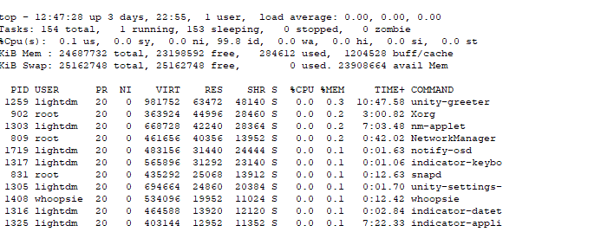

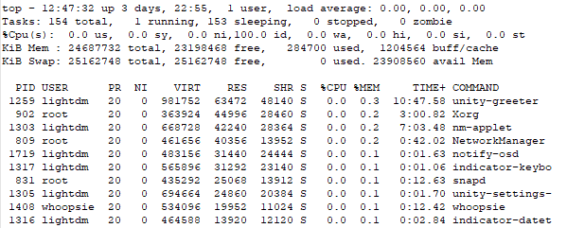

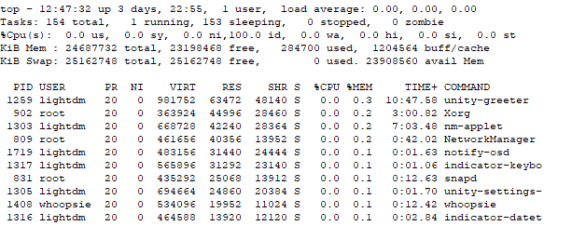

For complete data see Problem2_partb_memstats file using notepad ++

**Problem 3.** *(20 Points)* **Basic Linux tasks, use of tools.** Install iperf traffic generator on your system. Run iperf command (iperf -c *< ipofyourVM >* -t 10 -l *< packetsize*(*eg*100*B*) *>* ). Keep doubling packet sizes from 100 B to 6400B for different run. What is the average throughput achieved by the iperf data transfe for different packet sizer? Explain your observation. (Note: Before running client you nee to start your server iperf -s *< ipofyourVM >*)

(*also file available in the folder question123)

**With the increase in packet size i,e(doubling the size of packet)the throughput and bandwidth is almost getting doubled as TCP performance increases**

**with the increase in packet size the no of system calls to be made becomes less.**

**Problem 4.** *(50 Points)* **Slow server Problem.**

1. **Monitoring Script**

Write a shell script to do the following tasks:

* 1. Log the CPU load averages in a CSV file with T second granularity. (format of csv: timestamp,

1 min load average, 5 min load average, 15 min load average)

* 1. Generate alert
     1. ”HIGH CPU usage” if CPU usage in last one minute is more than a user defined threshold X .
     2. ”Very HIGH CPU usage” if CPU usage in last 5 minutes is more than a user defined threshold Y and load is increasing.

Log alert messages in a separate CSV file as timestamp, alert String, CPU load Average

Test this script by running a cron job. Submit your script (with readme) and a graph showing one minute load average taken every 10 seconds over 10 minutes duration.

1. **Log cleaning scripts** A script to clear log files every hour (You can use cron job or log rotation ) 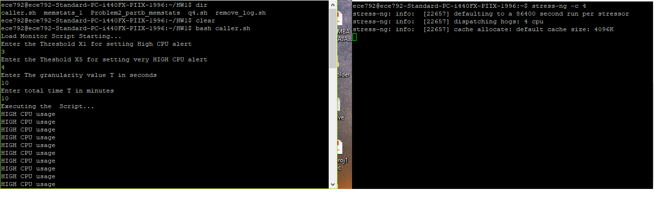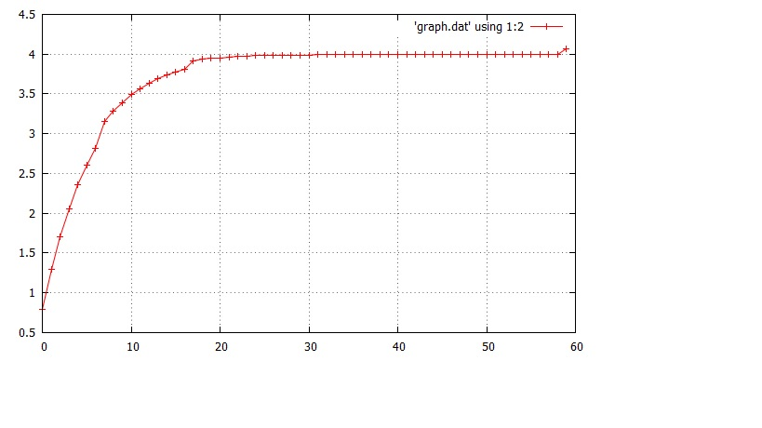 X-axis time T, Y axis 1min load %